The Newsletter for Middleton on the Wolds

Issue No 21

November 2020

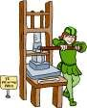
NEXT COPY DATE
14th November

Please send in your contributions to middletonflyer@yahoo.com by the end of the copy day. If I don’t acknowledge them please get in touch to make sure they have arrived.
I was delighted to receive the photo of the potato harvest from Hazel which she took specifically with the Messenger’s front page in mind. I’m sure there must be other keen photographers in the village who could send in a topical picture.
Thank you to a newcomer to the village, Karen, for her Rainbow poem. We are always pleased to receive articles, poems, recipes, quizzes etc ….
Lyn
4 The Paddocks 219500
Front Page Photo
The picture of the potato harvest on Station Road was taken by Hazel Kazer.

editorial
Much ado about traffic again this month; and on Station Road, too! It looks like they think they’ve finished resurfacing the pavement – but why have they stopped halfway round the most awkward section on that tight corner? Mind you, I don’t think there’s the room to widen it there. Anyway, there clearly isn’t room for a lorry to get round safely as it is if the side of June’s house is anything to go by!
The other topic rearing its ugly head is the re-introduction of more stringent COVID 19 restrictions. Whether Boris has got it right or not is for others to decide but, given the increased infection rate, he had to do something. Now, we are currently in a medium risk area, which means that our rules are a little less onerous than other areas but it’s up to us to abide by those rules so we don’t get pushed up to the next level. We all have family we want to see (one of our sons lives near Leeds so visits are a complete no no, and that probably includes Christmas) but isn’t it better to forego a hug temporarily than, possibly, permanently.
We are living in strange times and it’s up to us to adapt to them. If you can’t do what you usually do (say, bell ringing) then find an alternative (gardening).
Meanwhile I’m trying to find out whether putting a pickled egg in my packet of crisps constitutes a full meal!
Stay safe.
Cheers,
Mike
If you have any ideas, comments or complaints (especially complaints) you want to share then send an email to middletonflyer@yahoo.com.
Remember, we can’t respond unless we receive your message.
My editorial last month raised some very important issues concerning traffic in the village, especially on Station Road.
Regardless of the unusual situation of the resurfacing work carried out last month the problem of traffic on Station Road is one that needs as much public airing as it can get. As I see it there are three traffic issues here: parking, HGVs and other vehicles too large for the road, and speeding. Of these the least important is that of parking. This is not a major road and I realise that not all properties have access to off street parking so I can’t see why residents shouldn’t be able to park outside their own homes. The problem of large vehicles has been highlighted by events relating to the recent diversion of traffic, especially on the tight corner opposite the takeaway. One of the causes, here, is that SatNav sends drivers on this route although it does not, of course, advise people to drive like idiots. Finally, I agree that the main problem is that of motorists not driving within the speed limit or, at least, at a speed suitable for road conditions. There is a clear need for some kind of traffic calming measures, but what, exactly? This is why we need, as a village, to discuss this.
As to the tone of my editorial my aim is never to ridicule or humiliate but I will always, and I make no apology for it, try to get some kind of response on subjects that I believe are of relevance to village life. My view is that if we don’t talk about things then nothing ever improves. I hope this makes my position clear. Mike obituaries

Mave Proust 19/4/1945 to 15/9/2020
Mave passed away peacefully in Beverley Community Hospital with her husband Pat at her side after a long, brave 3 year struggle on 15th September.
Pat and Mave, with their daughter Melanie, moved into a newly built house on Greenfield Road in 1977. Their son Christopher was born in 1978.
Mave helped to run the newly started toddler group with new arrival mums and joined in many activities. She helped to run the cub group with Mrs Kemp after Pat, who was the cub master, had to give it up due to work commitments.
She loved to go to line dancing, loving dancing and music and was a keen gardener.
Their dream house was built in 1987/8 in Thompson Drive but they downsized to a bungalow in Hutton in 2019. Mave was very sad to leave but ill health forced the move. She still kept in contact with many friends in Middleton and had many happy memories of the village.
A celebration of her life was held at St Andrew’s Church, Middleton on Monday 5th October.
She was one of a kind.
A SHINING LIGHT HAS GONE OUT
RIP

Above is a photo of Mr & Mrs Firth on their last day in the shop.
The Family of Mrs Firth kindly advised Villagers that Marjorie had passed away on the 24.09.20. Mr & Mrs Firth owned a Grocery Shop next to the units on Front Street for 27 years, until they retired in 1991 which was a great loss to the village. They had a large garden at the back of the shop and David grew many vegetables and fruit trees in the garden, when in season these were also sold.
Many of the villagers can remember both David and Marjorie delivering weekly newspapers around the village before they opened the shop in a morning whatever the weather. They also welcomed anyone into the shop with a chair in one corner so that any lonely person could have a chat and a cup of tea.
The children were able to buy penny sweets (flying saucers - black jacks etc) on their way home from school.
They were also members of the Chapel opposite the shop and both took part in many events such as the Garden Fete which was held at North End House on Station Road each year and also participating in the annual Carol Singing around the village and outlying farms ending with Hot Drinks etc afterwards in various homes.

LOCAL HISTORY
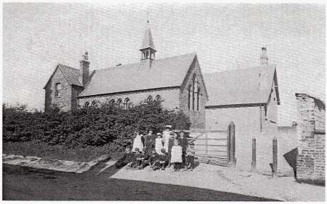

SCHOOLDAYS – THE STATE TAKES CHARGE
On the first day of October 1872 Arthur Appleton together with thirteen other children became the first admissions to the new school which had been designed by S Rollinson of Sheffield and built in Front Street by W Eastwood of Middleton. It was the start of a new age in education under the 1870 Education Act which in Middleton was controlled by the Church of England. From Cornwall came Edmund Hill as headmaster and his wife Susan as seamstress. Their daughters Laura and Helen were also admitted that day the latter eventually becoming a pupil teacher. The family lived in the school house and like their successors took an active part in village life.
Three days after opening Mr Hill recorded in the school log that he was giving special attention to reading, writing and arithmetic which had been badly taught in the village and he tried unsuccessfully to remove the “sing-song” tone when the pupils were reading aloud. Some general progress was made however and four years later the grammar taught was said to include nouns, verbs, adjectives and adverbs whilst geography teaching included the counties of England and in history The Crusades. Object lessons were also a feature and the children at that time did their written work on slates. However Mr Hill sounded a note of concern in his log entry for the 16th November 1875 stating “One great cause of failure is the want of intelligence arising no doubt from the fact that most of the children being related.” Mr Hill and his wife resigned from the post in April
1876 following a surprise inspection which revealed irregularities regarding
pupil attendance. The family returned to Cornwall where he obtained a similar post He died in 1925. He was succeeded in Middleton by two brief headships those of Henry Whitaker and John Price.
In 1880 school attendance was made compulsory and fees were abolished in 1891. Also in 1880 singing from notes (tonic solfa) was introduced and the children learned such songs as “ Since first I saw your face”, “The last rose of summer”, “God bless the prince of Wales” and “Ring the bell watchman.” Captain Brooksbank visited the school regularly and Mrs Brooksbank made frequent appearances to inspect the sewing. In keeping with its church school status the rector, the Reverend Blanchard, a kindly man, often visited the building to gave scripture lessons the quality of which was assessed during the annual diocesan inspection, while the teaching of other subjects was judged during separate HMI visits.
In those early days the teacher’s lot was not an altogether happy one. The Certificated System had been started in 1846 and lasted in that form until 1906. A pupil teacher could be apprenticed at the age of 14 and subsequently secure a certificate through attendance at a training college or a course of part -time study. In 1875 the average annual salary for a male certificated teacher was £109 and £65 for a female. Nor was their standing particularly high. A Government Minister once likened the notion of consulting teachers about what should be taught to “Asking chickens with which sauce they should be served.”
Something of the prevailing attitude to education in the higher echelons of society is neatly summed up in a letter to “The Times” newspaper in 1867 which reads “ The lower classes ought to be educated to discharge the duties cast upon them. They should also be educated that they may appreciate and defer to higher cultivation when they meet it; and the higher classes ought to be educated in a very different manner, in order that they may exhibit to the lower classes that higher education to which, if it were shown to them, they would bow down and defer.” Things would need to change. Geoff Wisher
The wolds METHODIST CHURCH bainton
November 8th 10.45am Remembrance Sunday, service at St
Andrew’s Church, Middleton

Other services will be held at Bainton Chapel in November. Please contact a church member for more details

A note from your vicar
Remember, remember the fifth of November,
Gunpowder, treason and plot;
I see no reason why gunpowder, treason Should ever be forgot.

Guy Fawkes, Guy Fawkes, it was his intent
To blow up the King and the Parliament; Three score barrels of powder below, Poor old England to overthrow.

By God’s providence he was catch’d
With dark lantern and lighted match; Holler boys, holler boys, make the bells ring, Holler boys, holler boys, God save the King.

In 1605, a time when very few people were literate and well before you could find out what was going on in the world at the click of a button, it was very difficult for news to spread around the country – especially into remote villages. King James I was only two years into his reign when Robert Catesby and his 12 men, including Guido (Guy) Faulkes had attempted to blow up the Houses of Parliament and the King. In doing so they hoped to begin a rebellion in the land and restore a Catholic head of state to the throne. As we know the plot was foiled after one of the men warned a family friend not to attend Parliament that day – that friend informed the authorities. Condemned for high treason Guy Faulks was mutilated and killed – the torture and grizzly deaths one human being can invent and inflict on another are horrendous!
The government needed to find a simple and effective way of deterring others who might think about killing the king – an easy and memorable rhyme would be just the thing.
The following year, a sermon was commissioned by Parliament to commemorate the survival of the monarchy and an annual custom was established – you can still find it in old copies of the Book of Common Prayer. A prominent Clergyman – Lancelot Andrews (who co compiled the King James Bible) read the sermon then recited this poem so that the worshipers would remember it and share it when they returned to their towns and villages.
Lamplit processions took place all over the country in honour of the king and huge fires, on which they burned effigies of the plotters, were repeated each year. Fireworks later replicated the explosion which might have taken place.
Such bonfires were normal at the time, with effigies of England’s ‘enemies’ burned on village greens across the land. Today, thanks to ‘Remember, remember the Fifth of November,’ it is specifically the Gunpowder Plot that is never ‘forgot’.
Jane
St Andrew’S church
November Services

Sunday 1st.November. No service.
Sunday 8th.November. United Remembrance Service at 10.45.a.m.(note time). Rev`d Jane Anderson. All welcome.
Sunday 15th.November. Morning Prayer at 10.30.a.m.Rev`d Canon Kate Goulder.
Sunday 22nd. November. Morning Prayer at 10.30.a.m.Rev`d Ruth Newton.
Advent Sunday, 29th. November. Benefice service at Middleton at 10.30.a.m.
(note time)
It is hoped to hold some Holy Communion services in December, using the C of E guidelines.
Keep safe. Keep well.

Recipe for Bonfire Night: Parkin

225g (8oz) Fine or medium oat meal
225g (8oz) S R Flour
225g (8oz) Brown Sugar
1 pinch salt
1 ½ Dessert Spoons of Ground Ginger
225g (8oz) Margarine or Butter
125g (4oz) Black Treacle
125g (4oz) Golden Syrup 1 Egg Beaten

Method :
Prep = 15 mins Cooking = 1- 1 ½ hours Oven 150c (170c) Gas 3

Put oatmeal, flour, sugar, salt, SR Flour & ground ginger in a bowl. Rub in the margarine or butter
Add treacle, golden syrup and egg
Mix well (it will be a heavy mixture)
Place in a lined, small roasting tin
Bake for 1 hour – 1 ½ hours (depending on your oven)

Parkin should be left to mature in a cake tin for 1 week (or at least 2-3 days) before you eat it. This will ensure a nice, sticky surface and a deeper flavour. This is Lancashire Parkin, I don’t know how it differs, if at all from Yorkshire Parkin.

Jane

QUIZ PAGE
The Electric Chair was invented by a Doctor, Dentist,
1
Optician or Scientist?
- Which US pop artist created ‘100 Campbells Soup Cans’?
- In publishing, what does POD mean?
- Girl Guides are for Girls between what ages?
- How old must you be before you can become president of the United States?
- Which politician/rock star used to appear on stage in a coffin?
- What model Aston Martin was originally used by James Bond?
- Christopher Cockerill invented what in 1955?
- Who wrote the 1873 novel ‘Around the World in Eighty Days’?
- In the game of Scrabble, the ‘M’ tile is worth how many points?
All answers on page 14 Quiz set by Rowland Wooldridge

^{SUDOKU} FOOTBALL DINGBATS
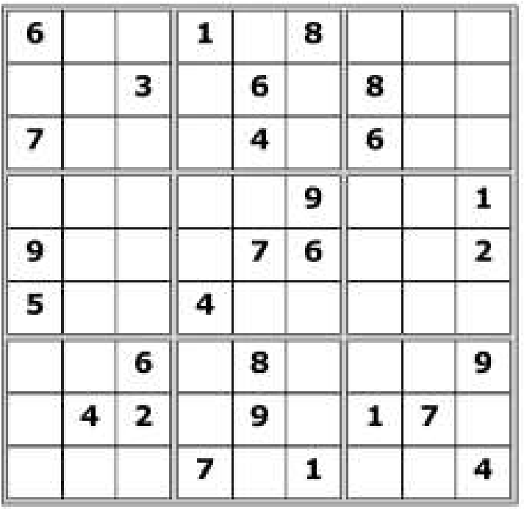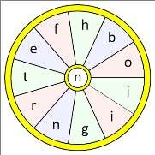
All answers on page
28

WORD WHEEL

This topical themed word wheel is
made from
2
words
. Try and find
these words, then make as many
words of any length as you can from
these letters. You can only use each
letter once, and each word must
include the letter

N
.

Village hall news
You may have noticed the decorative barrels full of plants which are now sitting in front of the Village Hall. The committee have donated these and our latest committee member, Denise Wales has planted these up for us. They do brighten up the frontage.
A reminder that committee meetings are now held on the first Tuesday in the month at 2.30pm in the VH.
New members are very welcome.

Village Hall Survey
On the next page you will find a survey form which we are asking villagers to complete and return to us so that we can find out what facilities and functions you would like to see in the hall and how we can try to adapt it for the needs of the majority once the pandemic is over. You can cut out and pop the completed form through the Village Hall letterbox or give it to the Parish Council members who will be collecting their play area survey on 21st November.
Thank you in advance for your help with this.
The Village Hall Committee
To book the Village Hall for a future event please contact Lyn Dennis on
219500 or lyndennis456@gmail.com

Reading room news
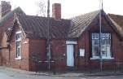
The Reading Rooms are now fully COVID compliant and are open for business. We have a QR code for check in with the NHS COVID 19 app, a sign-in sheet for those not using the app, and handwash is available on entry. We also have the facilities to introduce a oneway system if that is needed by users.
All we need is customers! I know it’s difficult to plan and hold viable meetings just now but it would help the committee if we could find out what you, the villagers, want to use the Reading Rooms for. Remember, we’re looking at the long term, here. Given that there may not be any significant relaxation of restrictions for at least six months that’s the kind of timescale we’re looking at. So, no rush but, if you have any ideas, please let us know.
For any of these topics please email me on mk@motwparishcouncil.co.uk.
Cheers,
Mike Kelly
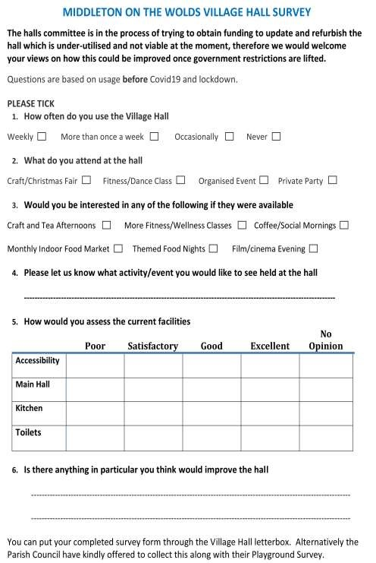
-
-----------------------------------------------------------------------------------------------------------------------------
---
---------


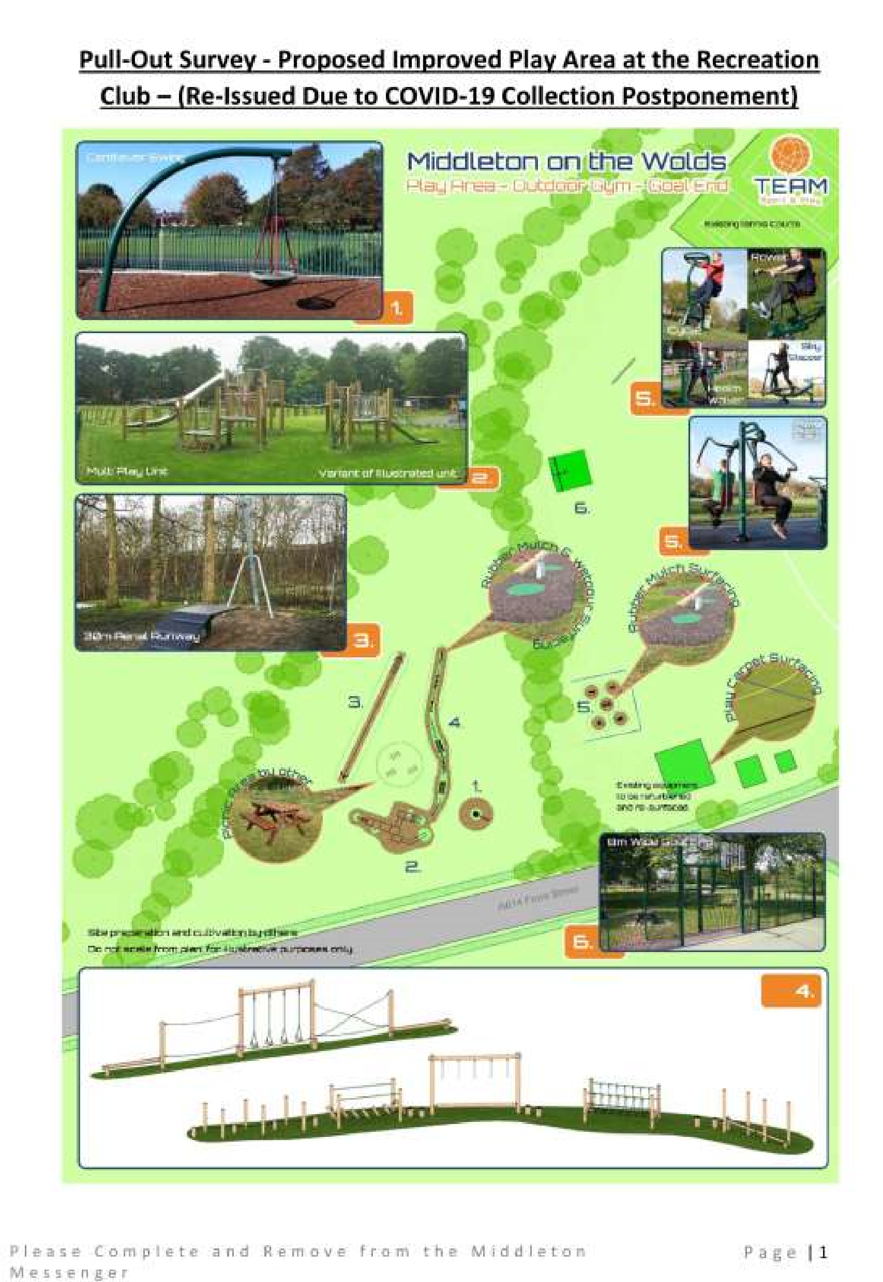

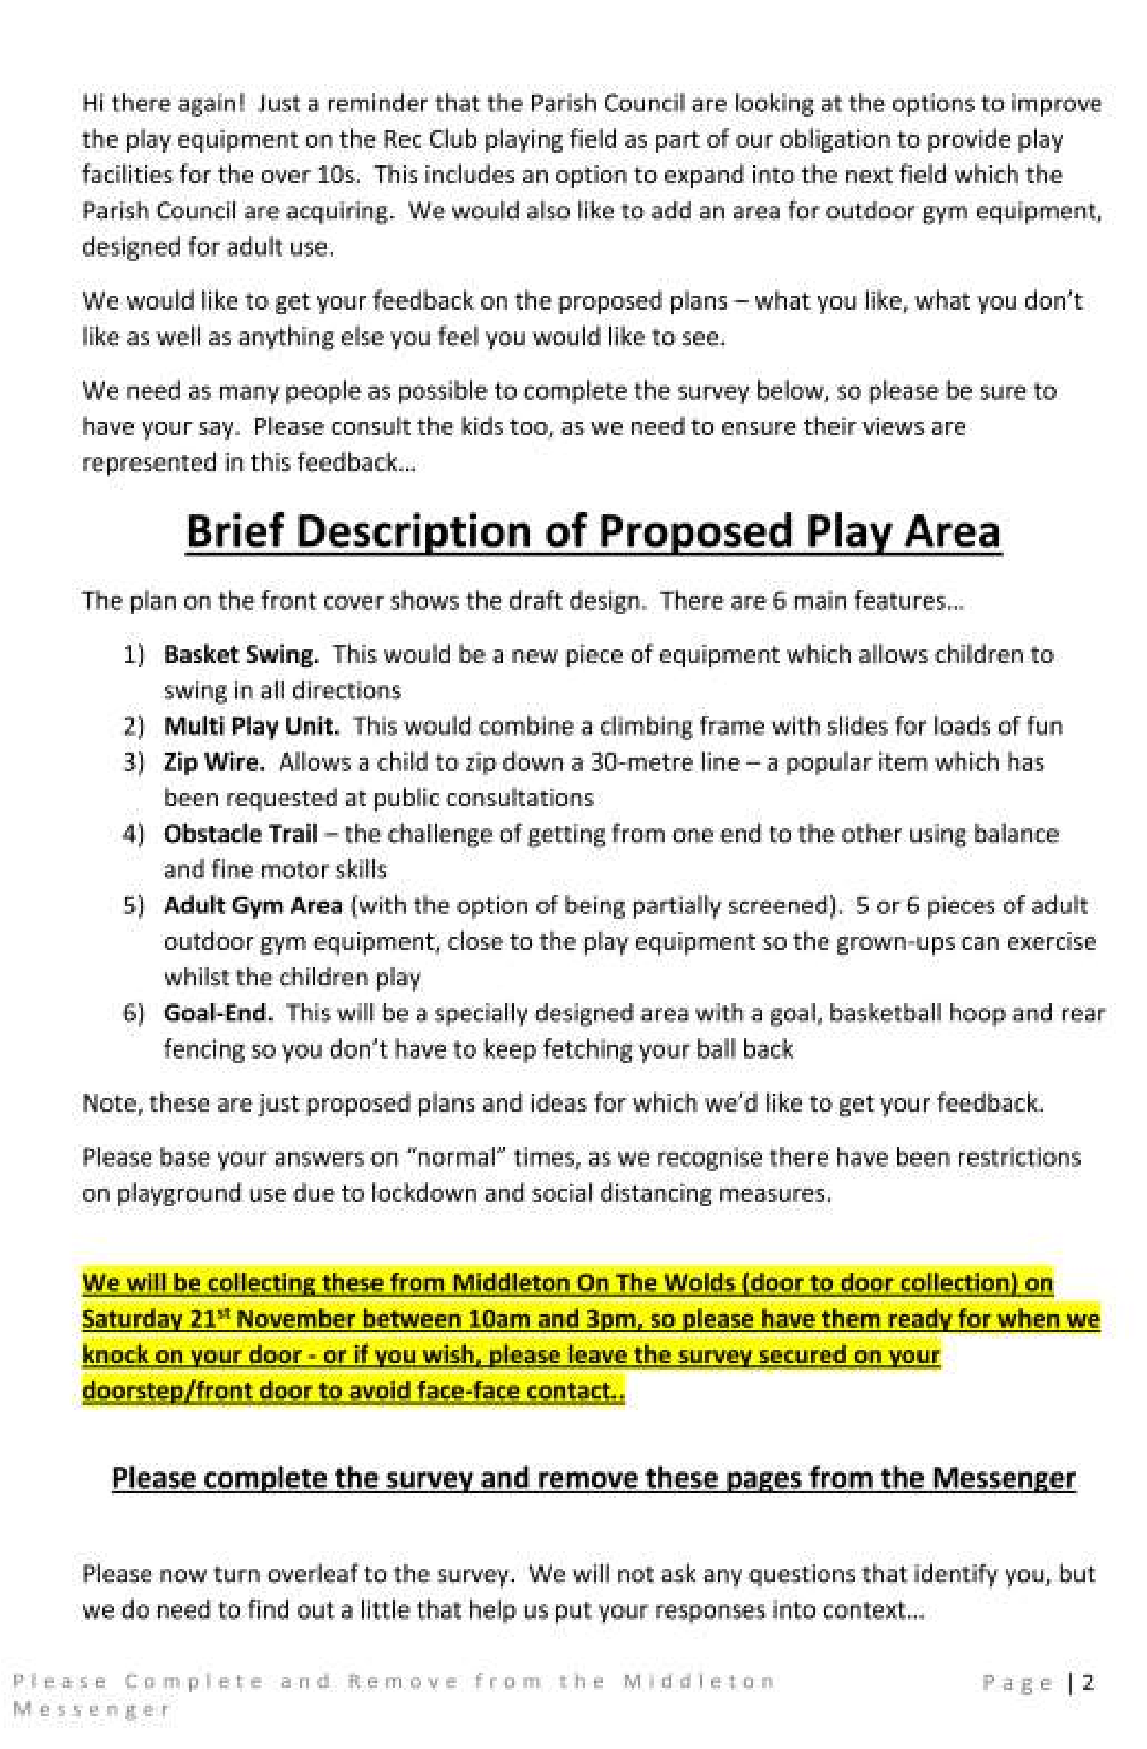

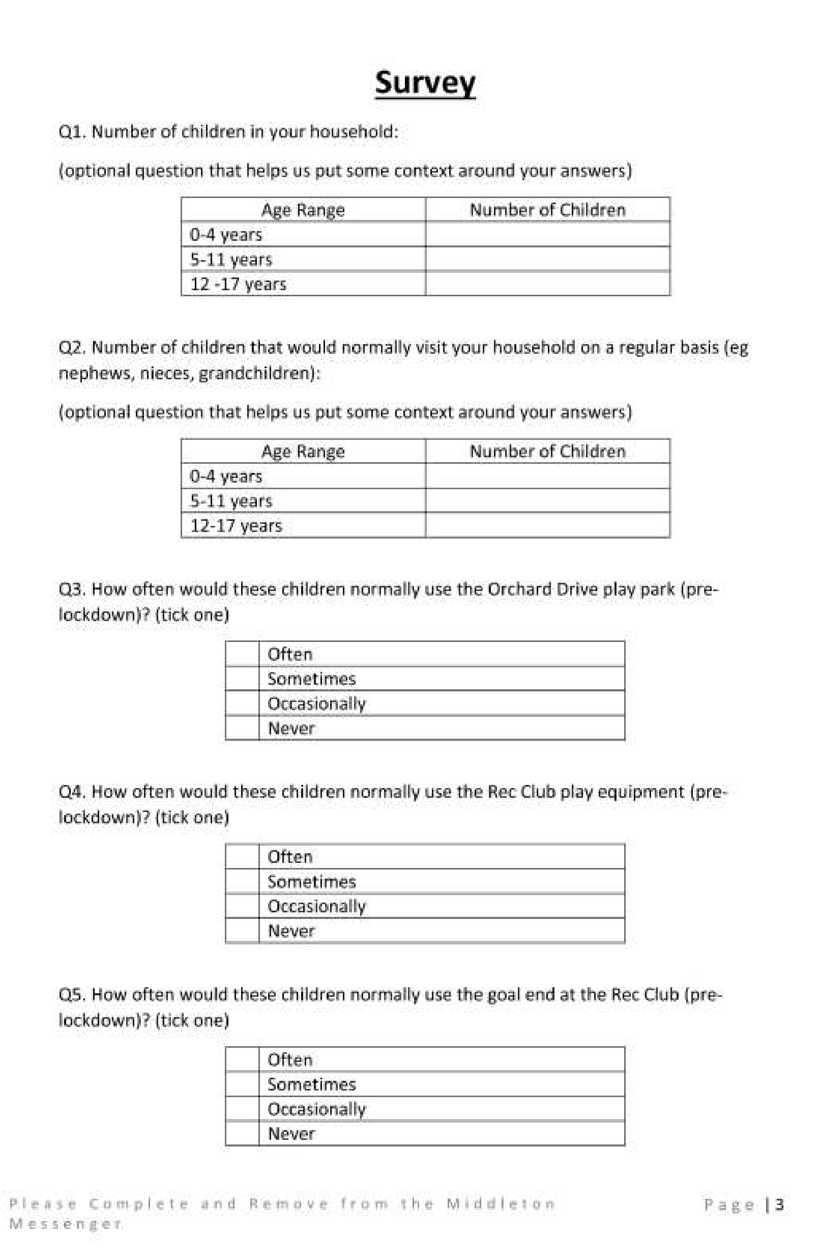

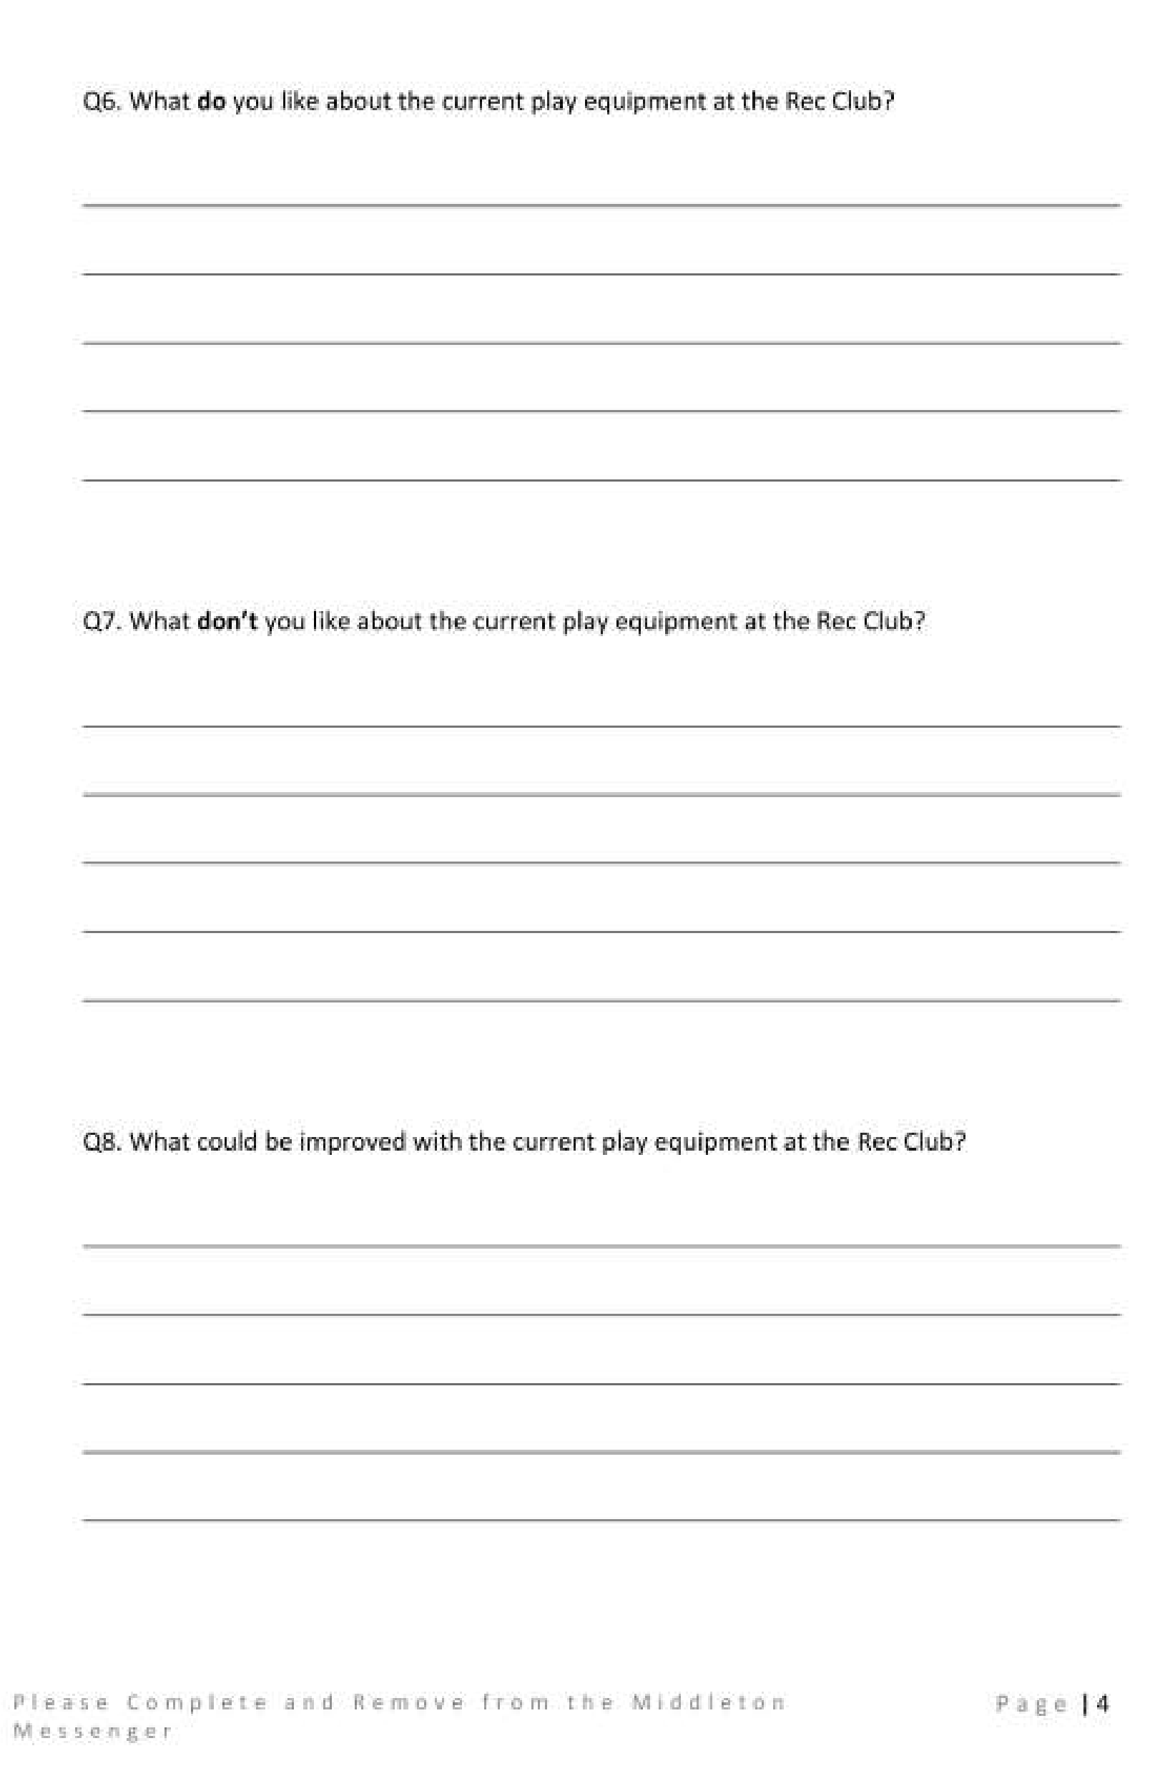

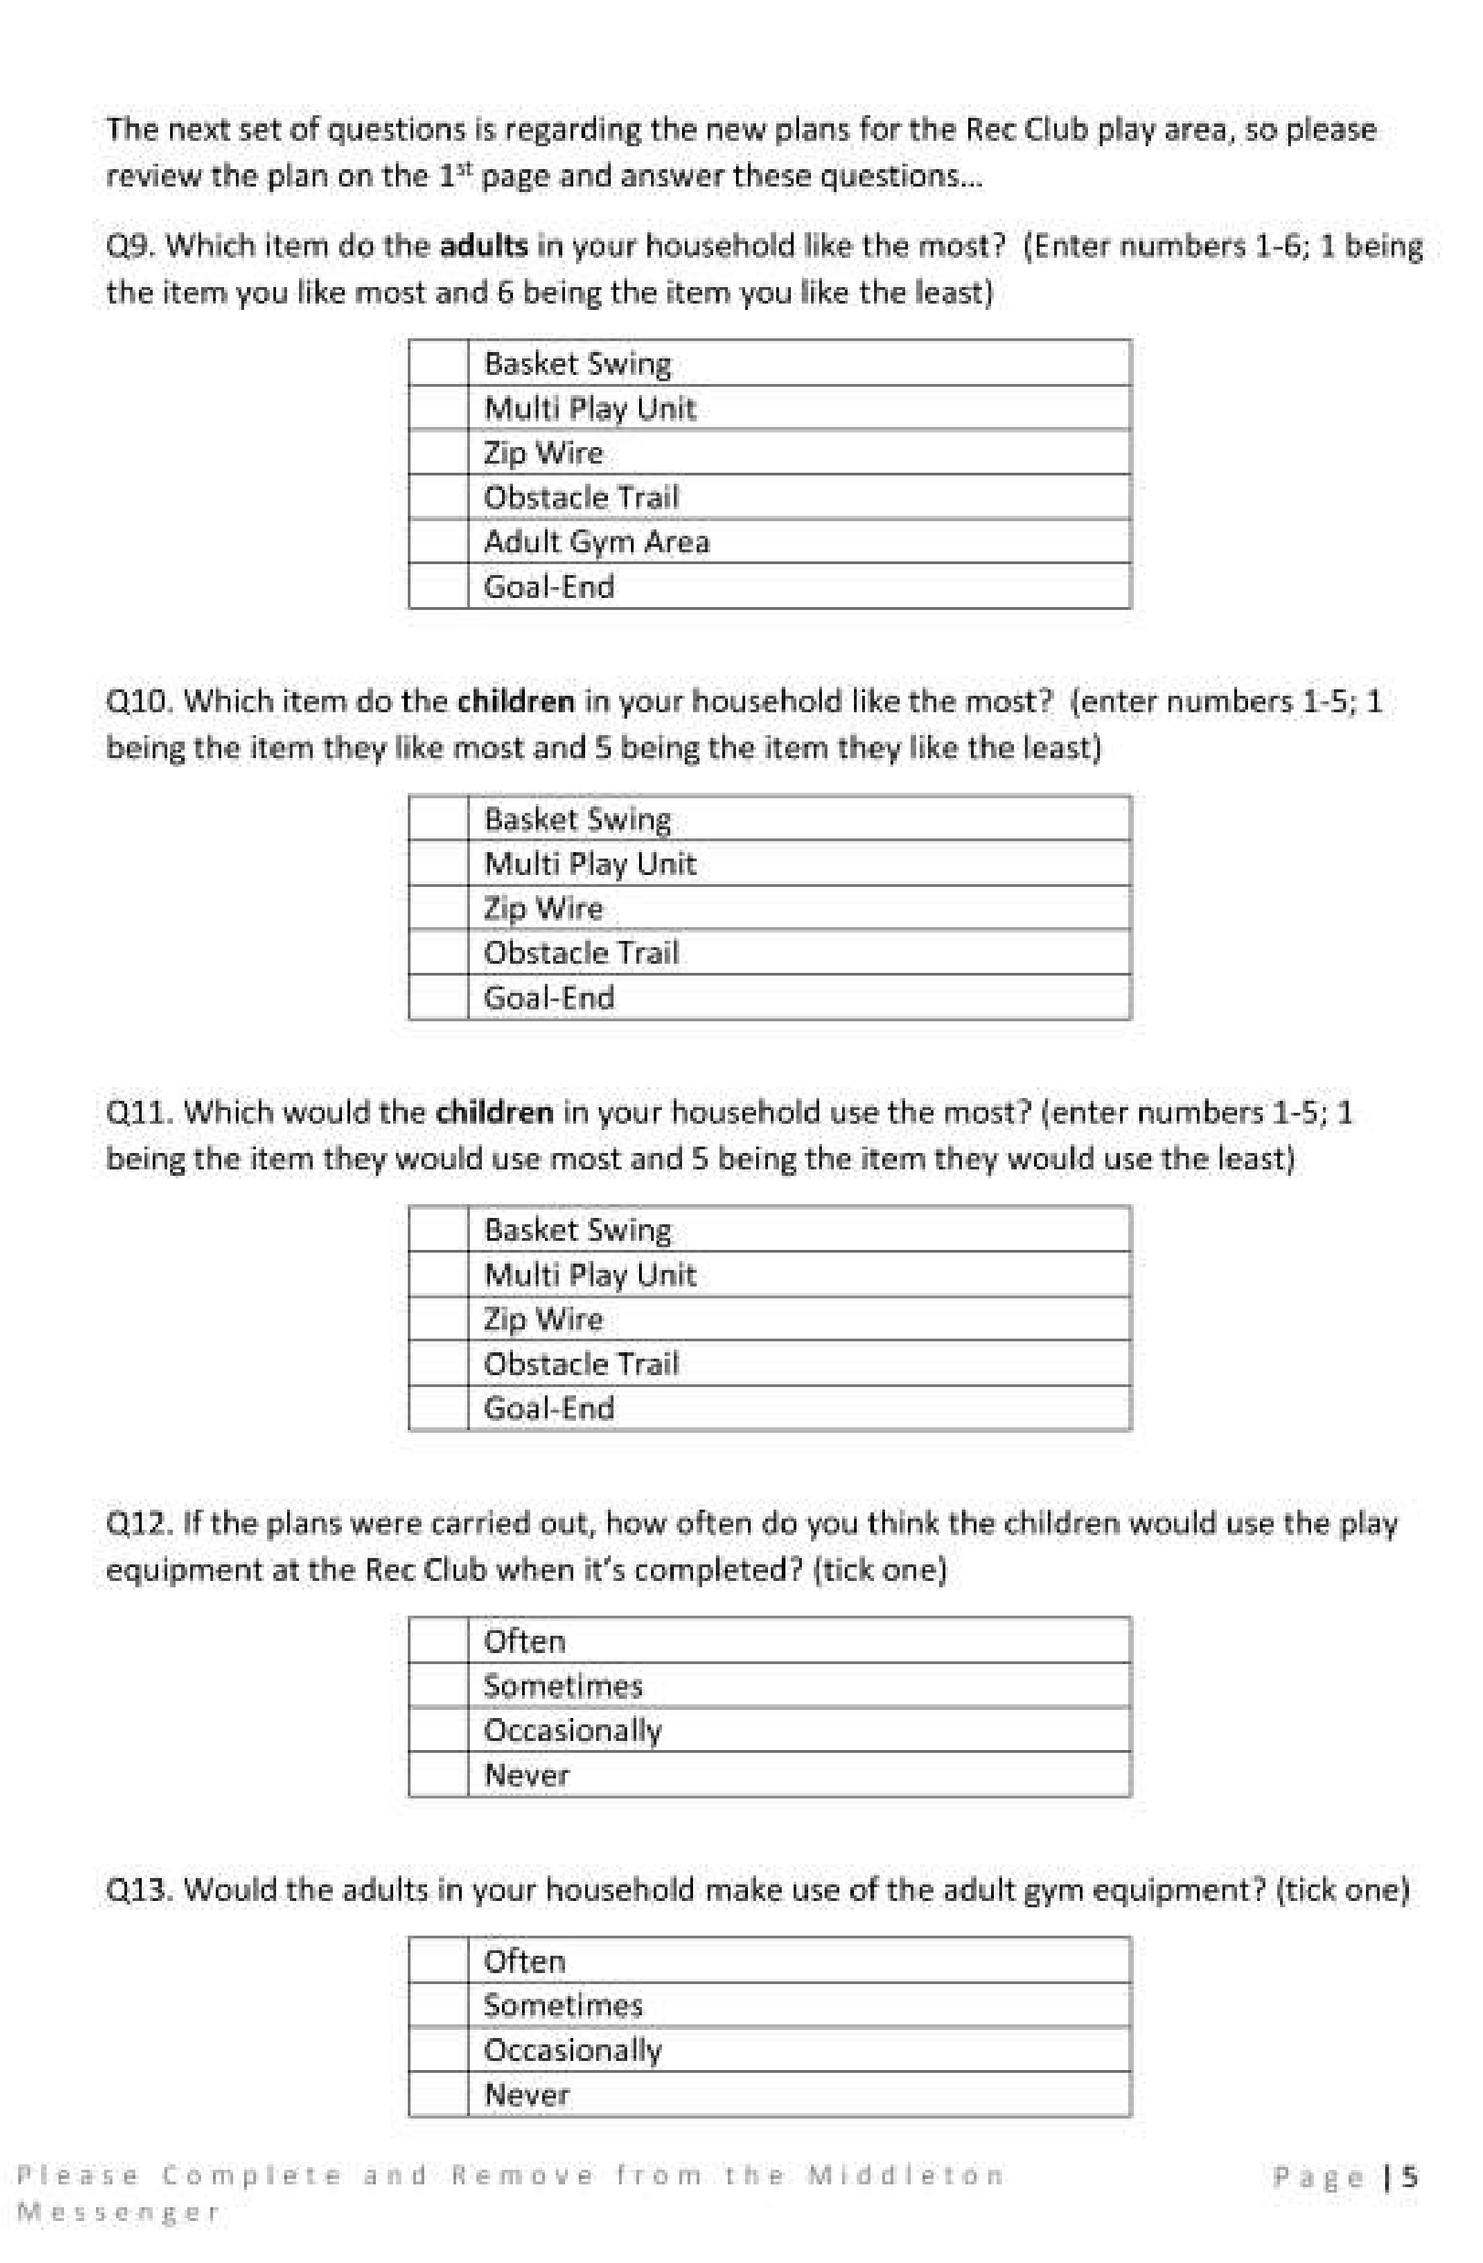

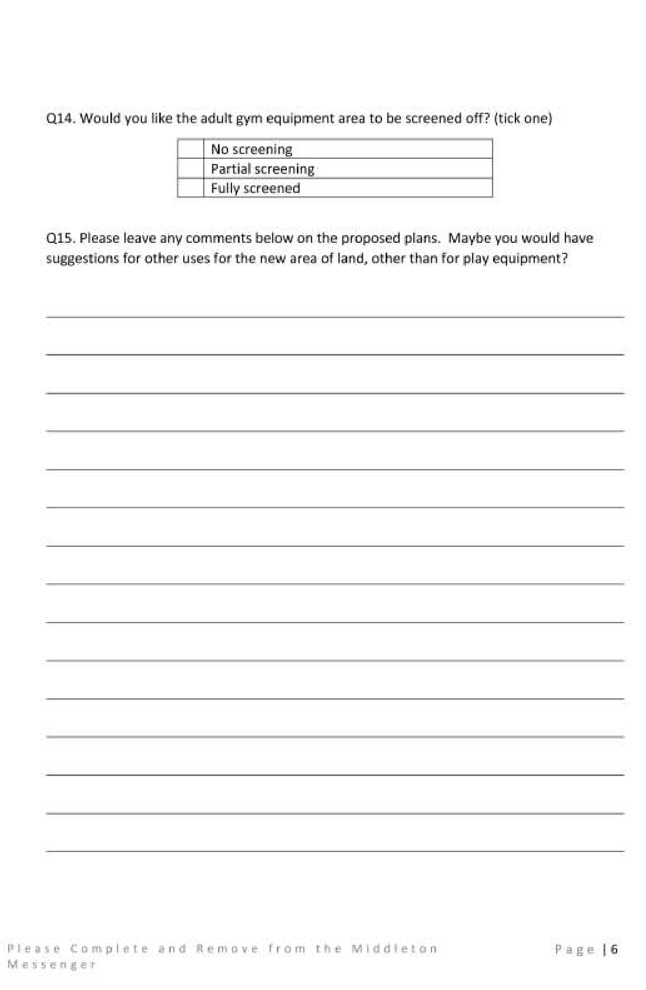

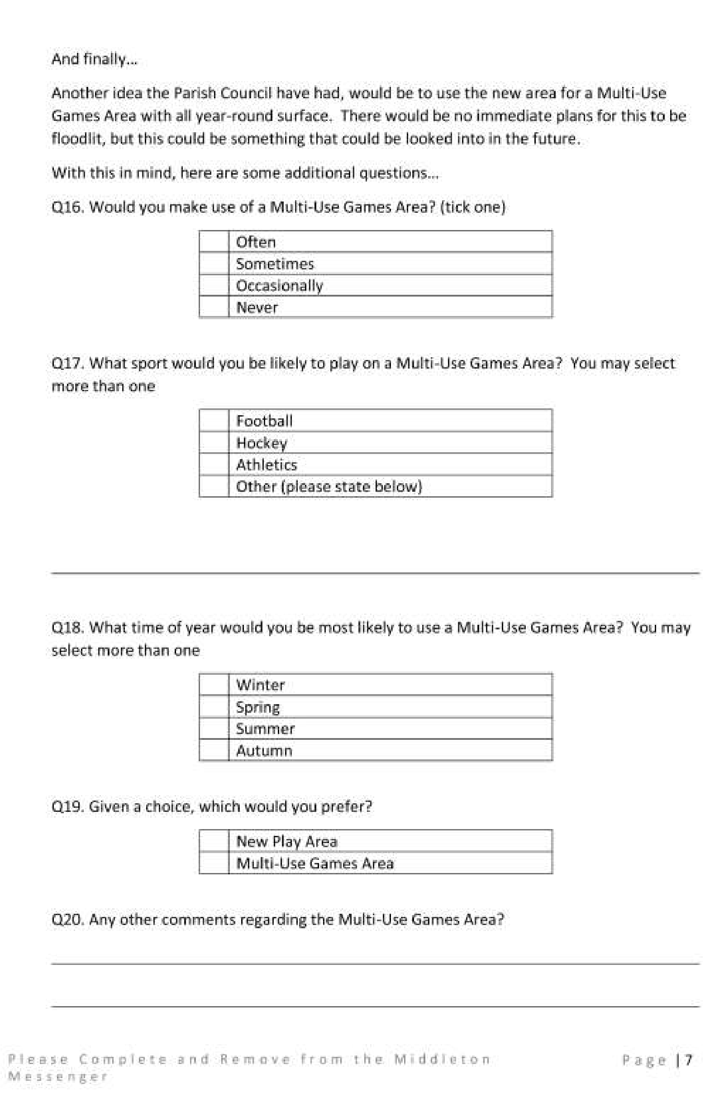

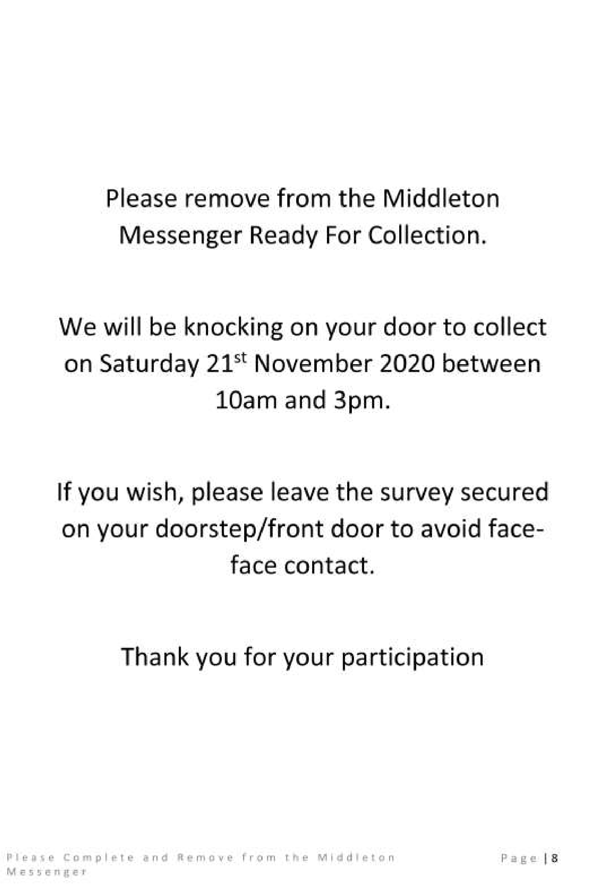

Parish council

Traffic
We have recently had a meeting with Wayne Goodwin the Community Speedwatch Coordinator from the East Riding of Yorkshire Council and we are in a position to start the ball rolling for our own Community team to monitor traffic along Station Road. Unfortunately we are advised that we are unable to monitor traffic on the main road (A614) as this is already controlled by Humberside Safety Camera Partnership; and Beverley Road cannot be monitored because it does not have a 40 or 30 mph speed limit.
The next step will be a power point presentation which will be done within Covid guidelines in the Reading Rooms; however the date of this is still to be confirmed.
This will then be followed by practical training on use of the speed gun.
Should you wish to volunteer to be part of this team please contact our Parish Clerk (pc@middletononthewolds.co.uk) or alternatively please feel free to approach any member of the Parish Council for further information.
Traffic problems have again been an issue, with recent nearby accidents causing further accidents and chaos in the village; causing damage to the Reading Rooms roof, and a resident’s boundary wall and their house. The diversion of traffic routes which are the decision of the local authority seemed totally inappropriate. Our concerns have been expressed to our Ward Councillor and we hope they would reconsider alternative diversions in future.
The Parish Council still has 1 vacancy for a Councillor, and anyone who feels they would like to apply and that they could help bring new ideas and support the needs of the village should contact the Parish Clerk either in writing or email. John Eastwood

Volunteers
The introduction of the latest system of COVID 19 restrictions should have reminded us all that not everybody will be able to cope without some form of help. The onset of winter will only increase the stresses caused by isolation, financial pressures, and, let’s be honest about it, the plain fear of not knowing what might happen next.
So this is a refresher to the call for volunteers from earlier in the year. The original list is still up in the Post Office and we will publish a revised list in the Messenger next month so people will have it handy. If there is anyone out there who isn’t on the list and would like to be please contact the Parish Council letting us know how you can help.
Mike Kelly

Middleton on the wolds ce ve school
Executive Headteacher: Mrs E Harros
Station Road, Middleton on the Wolds, Driffield YO25 9UQ
E-mail:middleton.primary@eastriding.gov.uk Tel: 01377 217323

Remembrance Service
We will be holding our remembrance service and marking the occasion in school with a service and a minute’s silence to commemorate Remembrance Day. Unfortunately, due to the current restrictions, we are unable to invite the local community to join us on this occasion.

Middleton Minis
Following Government guidance, Middleton Minis will not be running for the near future. Once we are allowed to re-open will inform you via the parish newsletters.

On-going Collections
On-going Collections – We collect used stamps and used batteries. Please note we are not currently collecting used printer cartridges or mobile phones until we can source a new company to collect and recycle them. Thank you.

Middleton on the Wolds Nursery
At Middleton on the Wolds CE (VC) Primary School  Providing education for 2, 3 and 4 year olds Monday - Friday.
 We accept the Government’s childcare vouchers for up to 30 hours of free provision for 3 year olds (conditions apply)
 Additional sessions can be purchased for £13.50 per session for 3 year olds and £15.75 for 2 year olds.
 Lunchtime sessions are £1.75 (free if children attend for the whole day) with the option to purchase a school meal for £2.40.
 Children are welcome in the term after their 3rd birthday for funded places.
For further details please contact: Sharon Stone
Email: middleton.primary@eastriding.gov.uk Tel: 01377 217323

School Dates
School closes on Thursday 22nd October and reopens at 08:40 am on Monday 2nd November.
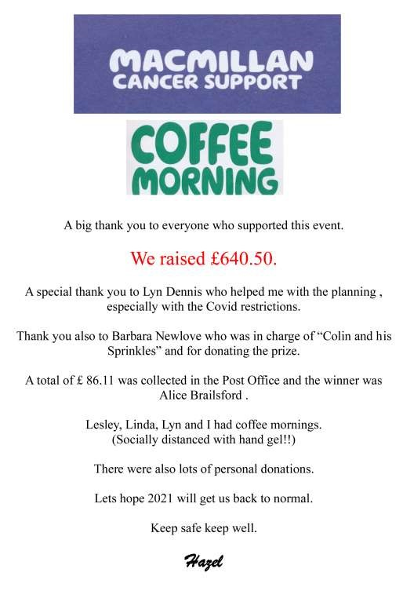

Local Birds & wildlife
I was hoping that this month I would be writing about how wonderful it was to hear the geese overhead, and possibly something about more birds coming back in the garden (I do sometimes plan ahead, although I inevitably end up writing this on the deadline day), but so far this isn’t working out. To be fair, I haven’t put any food out yet, so it’s no wonder the garden birds are giving me the cold shoulder. Luckily however, Hazel has come to my rescue, with the information that she has seen two small flocks of geese (40 – 50) flying south early in October and ten going north. I asked her if she had seen many chaffinches, as I have read somewhere that numbers seem to be down and there is some concern that they might be succumbing to the illness that decimated greenfinch numbers a few years ago, and she replied that although she has only seen the odd one in the garden she thinks a lot of the small garden birds might still be foraging in the fields. Let’s hope our gardens are full of chaffinches in a few weeks!
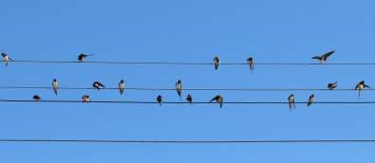

Of course I have been fretting about swallow numbers for some time now, and I was very happy to hear from Karen, who sent me this:
“Having read my ‘Middleton Messenger,’ I kept a lookout for swallows in the village.
I am delighted to report that they did pay a visit this year. For a couple of days in late August, I found a large number of swallows swooping over the fields behind South Street, evidently catching a lot of insects. They then gathered on the telegraph wires, preparing, like a band of brothers, for their big flight to Africa.
In the same spot, a month or so earlier, I had watched swifts skilfully catching insects and diving under the eaves of houses, feeding young in their nests. I suggest perhaps that the swallows were merely waiting their turn to pay the village a visit.”
On another subject, someone has something on his conscience; Ian writes:
“It was about 35 years ago The children were young and we bought them a swing. It looked a bit garish when we put it up on the embankment (the bit we don’t now own). Wouldn’t it be nice to grow something round the swing to make it rustic.
The Garden Centre chap said not to stand still next to it but I thought what harm could it do and planted it next to the swing and tied it in. Ignoring me it set off in the opposite direction and climbed trees. For the next decades it withstood all attempts to depose it by climbing the ash trees and hanging down to bring down the weaker boughs, but
Russian by name it rushed all over.
It does not seem to be causing any real mischief and the insects seem to like the flowers. At the moment it looks like a Japanese frozen wave as it attempts to overwhelm our dead hedge. After the somewhat brutal haircut the embankment had at the start of the year it is perhaps greening over the brash.
The swing has long gone, I hope the Russian Vine either follows it to oblivion or at least learns to behave.”
Finally, although Halloween will be over by now, I had a look for that most gothic horror bird, the raven, in my “Birds Britannica”. The association with death and all things spooky must have started with their love of scavenging on battlefields, and feeding from scaffolds, but they were also seen as useful down the ages for feeding on carrion in city streets. In ancient times (Mesolithic onwards – it says here) revered elders were left out on excarnation platforms when they died, for birds and animals to pick the bones clean before the skeleton was disarticulated and placed in a special chamber – one was found in Derbyshire, where ravens used to abound, about 15 years ago. On a more cheerful note, I also read that a raven called Hardey, aged 25, in the Tower of London, was successfully operated on for cataracts earlier in the 2000s, and a London Zoo vet said that the strangest job he had ever done was making a wooden leg for a Tower Raven.
So, getting back to Middleton, do let me know of any sightings around the area – or, for that matter, any strange and interesting birdie or animal facts you would like to share.
Contact me on lavenderbarbara97@gmail.com or 0777 192 7868 – I look forward to hearing from you!
Barbara
STOP PRESS: On the day of going to print (15th October) 400 to 500 geese were spotted flying over Middleton.
My Rainbow
My heart leaps up when it beholds
The mellow, autumnal Middleton on the Wolds!

So it was when I moved here in Spring,
So now I wait, to see what Winter will bring…
…In Spring I saw the blushes of your wild roses grow
Fading to the hippiest glow…
…In Summer the Spitfire Swifts soared overhead,
Roadside flowers bloomed like your Stars across the night..
…Here, in Autumn even the dead hold beauty tight, Faded colours enhanced whether by sun or moon, And your graveyard relaxes in heavenly light!
I wait for Winter on the Wold, as the year grows old, The Winter is father of the Spring; And I would wish my days to be Bound each to each, enjoying remembering, In my inward eye,
The Seasonal Middleton Mystery!
Karen Kaye

Middleton book group
Book Review of
Where the Crawdads Sing
By Delia Owens
Kya also known as The Marsh Girl is abandoned by her family and left to fend for herself.
She has various experiences and comes close to some folk but they let her down and she feels she is better alone.
The story is entwined with the murder of a young man. Kya is accused of his murder. She is put in jail and the tension of the court case means you can’t put this book down.
She uses her knowledge of nature to try to explain the behaviour of humans. She is highly intelligent and goes on to have books published which enable her to improve and modernise her ‘shack’.
A lot happens in this book and it is hard to explain it. You need to read it! I highly recommend it.

Book review of
The Sewing Machine
By
Natalie Fergie
This follows the story of the owners of a singer sewing machine from 1911 to the present day. You get to know all the characters who are likeable and this leads to a very satisfactory ending.
Judy

The weather has turned a bit chilly and wet for meeting in a garden so we were back on Zoom in October although we may get together (socially distanced of course) in the Village Hall while COVID regulations allow. For the short term we have changed the day of the Book Group meetings to Friday.

Next books for discussion:
“Sword of Kings” by Bernard Cornwell “This is Going to Hurt” by Adam Kay

To find out more about the Book Group please contact Lyn on 219500 or lyndennis456@gmail.com

SCOUT POST

Due to COVID 19 the Scout Post has been cancelled
this year.

Sue Howden

ADVERTISING COSTS for the Messenger
Rates Month Year

Whole Page £25 £150

1/2 Page £15 £100

1/3 Page £10 £60
Full colour - Print run 500 copies
Contact: Tina 01377 217242, middletonflyer@yahoo.com
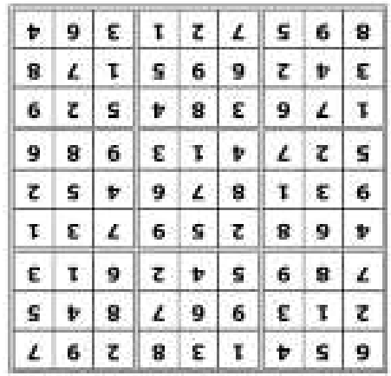
Quiz answers

Dingbats:

Between the posts

Centre half

Half time

Left wing

Match of the Day

Pay away from home

1

Dentist

2

Andy Warhol.

3

Print on Demand.

4

Ten to Fourteen

5

35
years

6

Screaming Lord Sutch

7

DB5 (1964)

8

Hovercraft

9

Jules Verne

10

Three

Word wheel: bonfire night

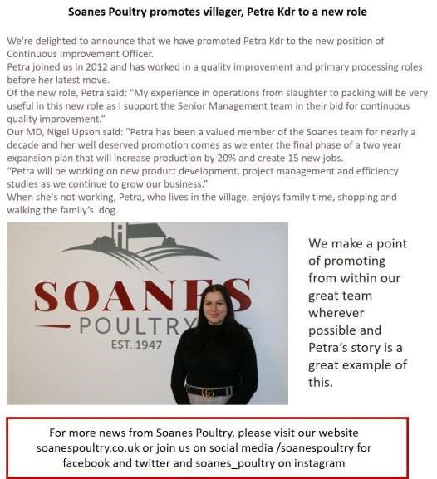
Advertising Feature

Advertisement
Advertising Feature

Regular group activities

Weekly Groups
Monday Pilates | 6.00-7.00pm Village Hall
Wednesday Line Dancing | 7.30-9.00pm Village Hall
Thursday Middleton Movers  November | 2.00-3.30pm Village Hall
2 Parish Council | 7.00pm Zoom
3 Village Hall Committee | 2.30pm Village Hall
13 Book Group | 2.00pm Ring 219500 for venue
22 Middleton Womblers | 10.00am Lime View

LOCAL CONTACTS Bell Ringing Chris Atkin |  | 217285
Book Group/Middleton Movers | Lyn Dennis | 219500
Bowls Club | Rob Bradley | 217435
Country Women’s Association | Christine Johnson | 217374
First Responders | Chris Brent | 219469
Line Dancing | Pat Pottage | 217516
Methodist Chapel | Jane Gray | 07870 562455
Middleton Messenger | Mike Kelly | 07713 620912
 | Lyn Dennis | 219500
 | Tina Walker | 217242
Middleton Womblers | Andrew Naylor | 219072
Parish Clerk | Sandra Morrison | 01262 470496
Pilates | Ian Stephenson | 07973 755717
Reading Rooms | Kath Bentley | 217456
Recreation Club | Dave Newlove | 07901 833784
St Andrew’s Church | Rev Jane Anderson | 219471
St Andrew’s Church Warden | Roger Lowe | 217656
Table Tennis | Louise Newlove | 217801
Village Hall | Lyn Dennis | 219500
Village History | Geoff Wisher | 217517

